***Resume***

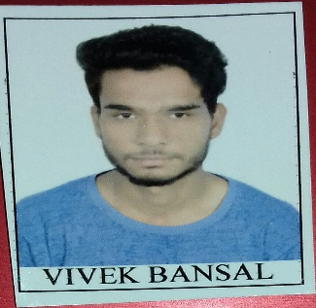**PHP Web Developer**

***VIVEK BANSAL***

Gwalior (M.P)  
***Contact no.:*** 8827433817  
***Email id*:** [bansalvivek16@gmail.com](mailto:bansalvivek16@gmail.com)

**Objective**

I want to utilize my skills and potential to achieve the challenging position in the Software Industry and fulfilling organizational goals.

**Educational Qualifications**

* BE computer Science Engineering from MITS Gwalior with 58%.
* HSC from Ashish Convent School with 69%
* SSC from C.N Convent school with 67%

**STRENGTHS**

* Able to multi-task.
* Learn new Skills quickly.
* Ability to work in team as well as in group.
* Positive Attitude, Confident, Responsible, Adaptable, Creativity.

**Technical Skill**

* **Programming Language:** PHP Core and PHP Advance (Codelgniter- MVC Framework **)** | C , C++(basic) |
* **Web technologies:** HTML5 | Javascript | Json | Jquery | bootstrap.
* **Database:** *MySQL.*
* PHP Framework Codeigniter
* **WEB Server**: WAMP
* Eclipse-Apache Tomcat.
* Operating Systems: Windows.
* Tools / Software: Notepad++, TextPad.
* Oops Concept

***OTHERS:*** MS Word | Power Point | Excel | Internet Surfing |.

**Certifications**

* Certificate Course in Programming Java Core from Numeric Infosystem . Pvt. limited Company Gwalior in 2017.
* Certificate Course in Core PHP & PHP Advance from Numeric Infosystem. Pvt. Company Gwalior in June 2018.

**Project Details & Experience**

**PROJECT TITLE :** *URBANSERVICES*

**Technology Used :** HTML | Java Script | JSON | JQuery | PHP | Bootstrap | MySQL.

**Duration Time:** 3 Months.

**Description**: the main objectives of this project is providing services between client and workers. Workers as plumbers housekeeping repairing etc. This urbansevices services are depends upon users requirements. We provide a user interface registration form and a service demand form that is essential to better understand users requirements according to categories. Used CodeIgniter is a powerful PHP framework with a very small footprint, built for developers who need a simple and elegant toolkit to create full-featured web applications. PHP server scripting used for dynamic and interactive web pages.

**PROJECT TITLE:** INDIAN UNVERSITY SYSTEM

**Technology Used :** HTML | Java Script | JSON | JQuery | PHP | Bootstrap | MySQL.

**Duration Time:** 3 Months.

• *Experience****(6 months)*** *in web application development using PHP, HTML, JavaScript, Jquery and Code Igniter.*

*Knowledge in MVC Architecture from numeric Infosystem pvt. Limited Gwalior.*

**Personal Details**

**Name :** Vivek Bansal

**Father Name:** B.K Bansal

**Date Of Birth:** 20/06/1996

**Contact No.:** 8827433817

**Address:** G-13 Panchsheel Nagar Thatipur Gwalior (M.P) India.

**Hobbies:**  I Like To Watch Movie on Holidays, Listening Music, Reading And Others. |